**Case Study:** Case Study of a Banking Application.

Today ***The Bank of Colombo***’s IT department plays a major role in software development. Most of the internal systems and major systems such as Internet Banking were developed internally. Due to the continuous improvements of the existing systems and new developments are rapidly increasing, the It department of the bank is facing a difficulties of integrating different systems and maintain common re-usable modules. Therefore the Bank is interested in implementing Enterprise Service Bus (ESB) and that will allow the bank to:

• Increase agility by reducing time to market for new IT Solutions

• Connect different systems easily

• Manage common modules very effectively

**Existing Environment**

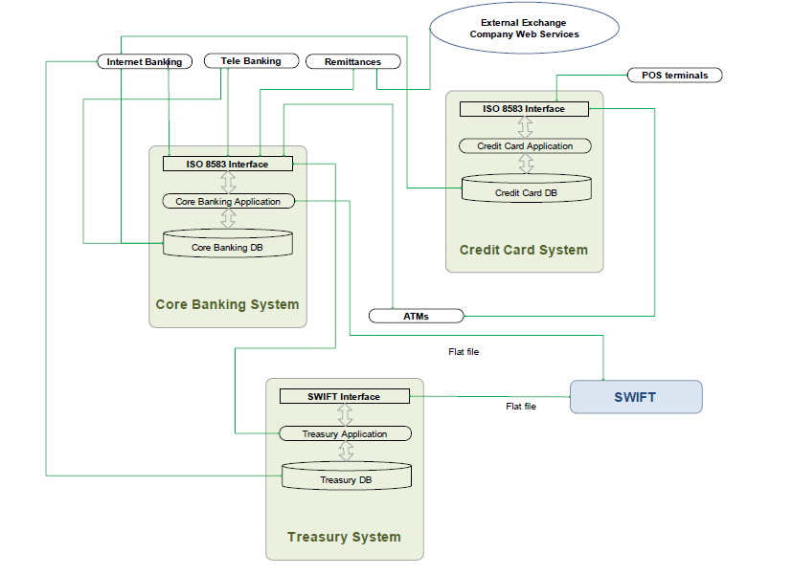

**Expected Environment**

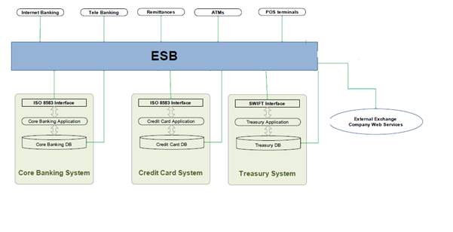

* Discuss the problem
* Identify Software Risks and Mitigation plan for testing.
* Identify your test strategy for figure out test plan for this new ESB integration.
* Document your test plan using IEEE standards